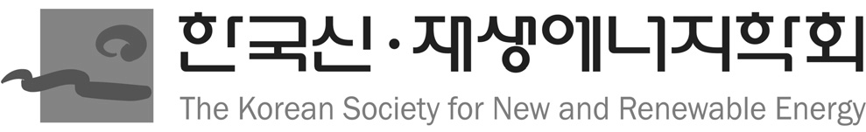

**COPYRIGHT TRANSFER FORM FOR PUBLICATION**

In order to ensure both the widest dissemination and protection of material published in New & Renewable Energy, we ask authors to transfer to the Korean Society for New and Renewable Energy (KSNRE) the rights of copyright in the articles they contribute.

Please provide us with the following information and confirm your acceptance of the terms of the copyright transfer by signing this form as indicated below.

**Title of article: Spatial Analysis of PV Potential in Gyeonggi Province: Impact of Irradiance Magnitude Differences and Policy Implications**

**Author(s): Seungho Jeon**

To be published in the New & Renewable Energy

This transfer enables the Korean Society for New and Renewable Energy (KSNRE) to provide the widest possible dissemination of the article through activities such as distribution of reprints, authorization of reprints, translation, or photocopying by others, production of microfilm editions, and authorization of indexing and abstracting services in print and data base formats. Without this transfer of copyright, such activities by the Korean Society for New and Renewable Energy (KSNRE) and the corresponding spread of information are limited.

The author(s) reserve(s) the following:

1. All proprietary rights such as patent rights.

2. The right to use all or part of this article in future works of their own, such as lectures, press releases, reviews or text books.

3. The rights of reproduction and limited distribution for own personal use or for company use for individual clients, provided that source and copyright are indicated and copies per se are not offered for sale.

Author agreement:

The copyright to this article is hereby transferred to the Korean Society for New and Renewable Energy (KSNRE), effective if and when the article is accepted for publication. If I am one of several co-authors, I hereby confirm that I am authorized by my co-authors to grant this Licence as their agent on their behalf. For the avoidance of doubt, this agreement includes the rights to supply the article in electronic and online forms and systems.

Signature: 블랙, 어둠이(가) 표시된 사진

AI 생성 콘텐츠는 정확하지 않을 수 있습니다. Print Name: Seungho Jeon

Date: 2025. 06. 13

Please send this form to the KSNRE editorial office by e-mail or fax.

The Korean Society for New and Renewable Energy

Room 908, Science and Technology Building, Youksam-dong, Gangnam-Gu, Seoul 135-703, Korea

TEL: +82-2-883-8051, FAX: +82-2-883-8042, E-MAIL: [ksnre@ksnre.or.kr](mailto:ksnre@ksnre.or.kr)

2015. 3 Vol.11, No.1 71